Introduction
This document explains how to use wiwCheck node.
wiwCheck manages communication states.
It is :
- optional (but recommended) when wiwMqttConfig’s wiwConnected parameter is set to true,
- mandatory when wiwMqttConfig’s wiwConnected parameter is set to false (otherwise nothing can be sent because Mqtt client is supposed disconnected).
The main goal of wiwCheck is to store messages when Mqtt connection is not available, and send them when connection comes back ON.

The flow
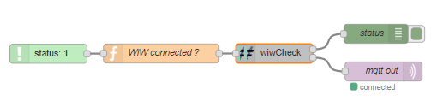
This flow has been created with node v10.16.0 and Node-RED v0.20.7.

Third party dependencies
A Mqtt broker must be running. See mqttBroker document for more information.

Explanation
This flow demonstrates how to use wiwCheck to manage communication states and avoid loosing messages (to some extent) when Mqtt broker can not be reached.

First line
The status node reacts to all Mqtt’s connection status modification.
The function node uses the status to setup the wiwConnected attribute. This attribute is then provided to wiwCheck node for it to handle the connection state to Mqtt.
wiwCheck’s first output provides current connection status and others properties explained in wiwCheck’s documentation.
When Mqtt broker comes back online, wiwCheck’s second output will provide every message stored while the connection was interrupted (in the order they have been added).

Note
Please make sure to use the right Mqtt broker settings in the Mqtt client setup.

